Question 1- David drew a column graph to show the average cost of petrol in six capital cities
Misleading Graphs Worksheet
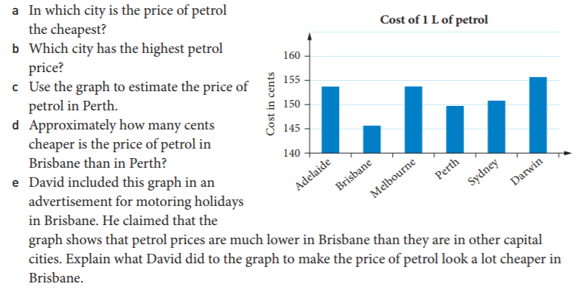
Question 2: Scott thinks that oil companies are ripping people off. He decided to investigate the price of petrol and the cost of crude oil. Scott displayed his information on a graph.
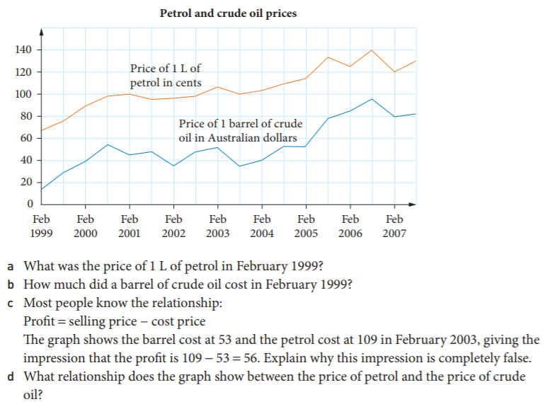
Question 3- This graph compares the average weekly wages in Malvolia ($700) and Australia ( $1400)

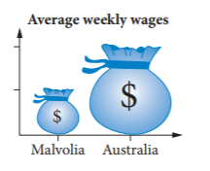 | 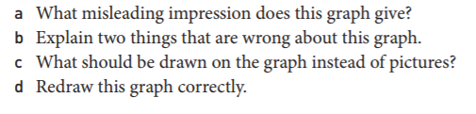

Question 4 : The number of graduates from a community college for the years 1999 through
2003 is given in the following table:

Year 1999 2000 2001 2002 2003
# of Graduates 140 180 200 210 160

The figure below shows the line graphs of the same data but with different
scales. Which shows the data fairly and why?

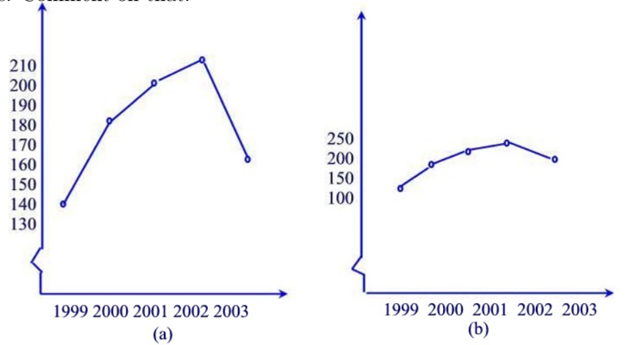

Question 5 : Suppose the following circle graphs are used to illustrate the fact that the

number of elementary teaching majors at teachers’ colleges has doubled be-
tween 1993 and 2003, while the percent of male elementary teaching majors

has stayed the same. What is misleading about the way the graphs are con-
structed?
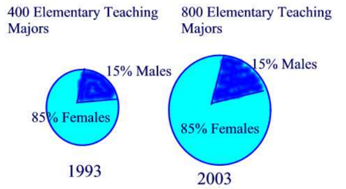

Question 6 : What is wrong with this graph?

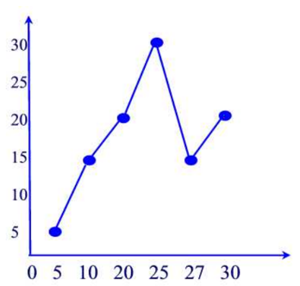

Question 7 : Ms McNulty claims that on the basis of this information, we can conclude
that men are worse drivers than women. Discuss whether you can reach
that conclusion from the pictograph or you need more information. If more
information is needed, what would you like to know?
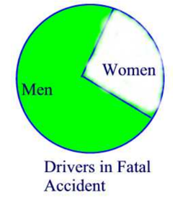

Question 7 : Which graph could be used to indicate a greater decrease in the price of
gasoline? Explain.
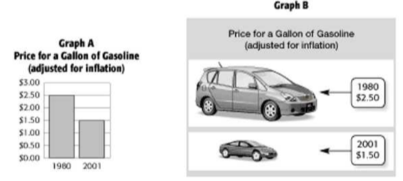

Question 8 : What is the error on this graph?
